**Women’s Economic Empowerment Community Engagement – IDEAS4GE**

**APPENDIX/WORKSHEETS**

* WEE / IDEAS4GE Event – Why Now/Goal Setting
* WEE / IDEAS4GE Event – Level of Engagement
* WEE / IDEAS4GE Event – Who & Techniques
* WEE / IDEAS4GE Event – Planning & Evaluation

Women’s Economic Empowerment (WEE/IDEAS4GE) Event Planning

*Why Engage Now? – Goal Setting Worksheet*

To assist with determining the goals of your WEE/IDEAS4GE Community Event explore the following statements.

|  |  |  |
| --- | --- | --- |
| Why hold a Women’s Economic Empowerment/IDEAS4GE Community Engagement Event in your community?  Check any of the statements that apply. ( √ ) | | |
| **( √ )** | **Purpose/Goals** | **Thoughts/Comments** |
|  | To share/explain what women’s economic empowerment and the IDEAS4GE is all about |  |
|  | To seek feedback on the benefits and challenges to achieving gender equality and women’s empowerment in our community, using a [GBA+](mailto:https://women-gender-equality.canada.ca/en/gender-based-analysis-plus.html) Inclusion, Diversity, Equity and Access lens |  |
|  | To engage related talent and gain support to apply women’s empowerment, gender equality, diversity and inclusion principles within their own sphere of influence and/or within the broader community |  |
|  | To garner support from community leaders from [Equity-deserving groups as defined in the 50-30 challenge Publicly Available Specification Document](https://secureservercdn.net/192.169.220.85/b0m.396.myftpupload.com/wp-content/uploads/2022/03/Di-PAS_EN_vf.pdf) and all stakeholder groups i.e. 1. ____ Government (all levels), 2. ____Business (all sizes), 3. _____Other  *OTHER: Includes all other stakeholders, entities and individuals within what we define as a broad third sector. It includes civil society and not-for-profit organizations, business associations, labour organizations, Municipalities, Universities/Colleges, Schools and Hospitals, (MUSH) and any other private and public sector that is distinct from government or business. |  |
|  | To engage the community in a planning process specific to developing policy, programs or services related to promoting women’s economic empowerment and gender equality through, inclusion, diversity, equity, and access. |  |
|  | To engage the community to celebrate leaders within the community who have been successful in advancing gender equality, through inclusion, diversity, equity and access within their organization and/or have integrated one or more of the seven women’s empowerment principles within their organizations’ routine operations. |  |
|  | To provide the community with tools and resources to help advance women’s economic empowerment and gender equality through, inclusion, diversity, equity and access. |  |
|  | To provide stakeholders interested in advancing women’s economic empowerment, and gender equality a forum to build partnerships, collaborate and share best practices. |  |

Based on your selections summarize your WEE/IDEAS4GE event key goals:

Women’s Economic Empowerment (WEE)

Women’s Economic Empowerment (WEE/IDEAS4GE) Event Planning

*Level of Community Engagement Worksheet*

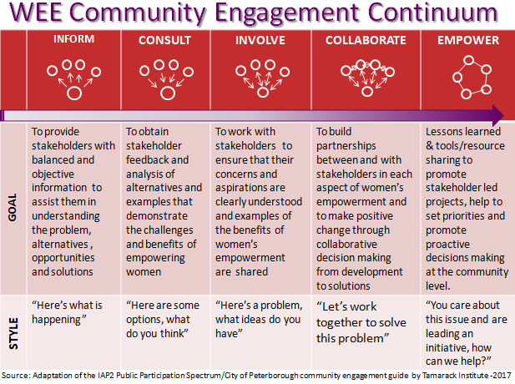

Consider your summarized Women’s Empowerment/IDEAS Event goals on page 10 and determine which levels of engagement as defined above most reflect your intention. Is it primarily to inform or consult? Or do you wish to actually involve participants to promote better understanding and purposeful follow through? Or perhaps it is to offer opportunities for ongoing collaboration and leadership for a proactive community / solution-building response?

Place a check mark in the appropriate level of engagement for each of your goals.

|  |  |  |  |  |  |  |
| --- | --- | --- | --- | --- | --- | --- |
| Goal | Inform | Consult | Involve | Collaborate | Empower | Comments |
| #1 |  |  |  |  |  |  |
| #2 |  |  |  |  |  |  |
| #3 |  |  |  |  |  |  |

Women’s Economic Empowerment (WEE/IDEAS4GE) Event Planning

*Who Should We Engage? - Worksheet*

Considering the goals and level of engagement that you set for your WEE/IDEAS Community Event you can define your event and begin to brainstorm specific stakeholders you want to engage.

|  |  |
| --- | --- |
| Who should we engage? | |
| **Questions** | **Community Members/Stakeholders/Leaders** *Government - Business - Other Organizations - Individual* |
| Who are directly impacted by the aims of this event? |  |
| Who will be indirectly impacted? |  |
| Who is already engaged or has contacted you about this issue? |  |
| Are there existing community networks working on this issue?  Are there existing community networks working on this issue? … continued |  |
| Who has unique skills, insights or resources to offer to your WEE/IDEAS community event?  Content Experts: *event are individuals and leaders with specific knowledge, tools, and resources that can help to advance women’s economic empowerment and gender equality, through inclusion, diversity, equity and access policies and practices.*  Context Experts *are individuals from any stakeholder or equity deserving groups with diverse lived experience. They experientially know the challenges, success and benefits of women’s economic empowerment and inclusion, diversity, equity and access. It is critical to use an intersectional lens when forming your pool of context experts. Experts drawing upon experience from a wide range of intersecting identity factors, such as race, ethnicity, religion, age, socio-economic status and mental or physical disability to list a few will contribute to an engaging and enriching program. Attention to the fact that there is considerable diversity in how individuals and groups understand, experience, and express gender and that gender is beyond biological (sex) and socio-cultural (gender) differences. Learn more about applying a GBA+ Gender-based Analysis Plus lens to your event planning at* [*Women and Gender Equality Canada GBA+*](https://women-gender-equality.canada.ca/en/gender-based-analysis-plus.html)*.* |  |
| Who should we engage? Continued…. | |
| **Questions** | **Community Members/Stakeholders/Leaders** *Government - Business - Other Organizations - Individual* |
| Who can exert power and/or offer support for your event? |  |
| Who should be invited to ensure a balanced representation across the various stakeholder groups? (i.e. Government, Business, Other, including Equity-deserving groups …) |  |
| Who do we need to approach to join our event planning committee? |  |

Women’s Economic Empowerment (WEE/IDEAS) Event Planning

*What Techniques Should We Use? - Worksheet*

A panel discussion and a combination of Women’s Economic Empowerment/IDEAS4GE Challenge presentations and activities in a workshop format is one of the engagement techniques found to be well suited to a successful WEE/IDEAS4GE community building event.

You may however, also use other community engagement techniques to support your WEE event. See next page for a list of additional techniques that may be incorporate into your event planning, implementation and follow-up activities.



Women’s Economic Empowerment (WEE/IDEAS) Event Planning

*What Techniques Should We Use? - Worksheet*

Based on your WEE/IDEAS event, goals and level of engagement consider if and/or how any of the Community Engagement Techniques outlined below will enhance your event. The engagement techniques used during your program planning may help promote your event. They may also be incorporated directly into your event program or used as a follow-up activity.



Identify possible persons on your event planning committee or community contacts that you believe can help to coordinate the implementation and use of the selected items according to your planning timeline.

Women’s Economic Empowerment (WEE/IDEAS) Event Planning

*Evaluating your Community Engagement Event - Worksheet*

It is important to plan how your will evaluate your community engagement event. Plan your evaluation and incorporate it into your program and adjust as you go along. Consider evaluation techniques that are based on your overarching goals, the level of engagement and complexity of the issues involved.

Things to consider in your evaluation: Did the event help to achieve your overarching goals? How did each of the engagement techniques used during event promotion, implementation and follow-up contribute to your goals?

It is recommended that you schedule a “debriefing session” immediately following the event so that you and your planning committee can explore both intended and unintended outcomes while the spirit of the event is fresh.

During the IDEAS Project Term, a pre and post event page is provided to all registrants on the general public Collaborative IDEAS4GE Solution-Building workspace.

Regardless of whether you used a traditional evaluation form, electronic feedback and/or Post-event workspace, the project team will compile and analyze the feedback to gain insights for future event improvements.

It will be very helpful to establish key metrics and data sources related to your primary event engagement goals.

|  |  |  |  |  |
| --- | --- | --- | --- | --- |
| Goal | Anticipated Level of Engagement *(*[*see pg 9 & 10 of the Guide*](https://ccew.ca/images/ccew/Resources/WEE_community_engagement_guide_ver4whynow22.pdf)*)* | Key Metrics  *(see more detailed metrics below)* | Data Sources | Comments |
| #1 |  |  |  |  |
| #2 |  |  |  |  |
| #3 |  |  |  |  |

**Example:**

|  |  |  |  |  |
| --- | --- | --- | --- | --- |
| Goal | Engagement | Key Metrics | Data Source | Comments |
|  |  |  |  |  |
|  |  |  |  |  |